Chapter 4 - 4.2 Preliminary Design or Design (Model) Specification
Rubric: CO5. Criteria: preliminary design of multiple alternative solutions of the system; perform simulation of the alternative design solutions for functional verification. Marks: 5 from the report + 10 from the defence panel.

What this section must do
Present the alternative designs considered for every part of the system, show the simulation evidence that decided between them, and then specify the selected design precisely. The BRAC template gives one sub-subsection per alternative and ends with "Simulation and Verification" plus a comparison table. Keep the detailed statistical analysis for Chapter 5. Here, show enough evidence to justify each selection.

Tables and figures in this folder
File | Use
figures/fig_final_architecture.png | Opens 4.2.1
tables/d1_evolution_mismatch_fix.csv | Why the initial GPT-2 detector was replaced
tables/d1_backbone_comparison.csv + figures/fig_d1_backbone_comparison.png | Detector alternatives
tables/d1_backbone_significance.csv | Short support for the detector choice
tables/d2_bakeoff_candidates.csv | Generator alternatives
tables/integration_variant_ablation.csv | Ways of passing d1's output to d2
tables/rag_negative_result.csv | RAG alternative
tables/configuration_and_hyperparameters.csv | Full specification of the selected design with a justification for each setting

Checklist
- ☐ 4.2.1 Overview of the selected architecture (figure)
- ☐ 4.2.2 Emotion detector alternatives (d1)
- ☐ 4.2.3 Response generator alternatives (d2)
- ☐ 4.2.4 Integration alternatives (how d1 reaches d2)
- ☐ 4.2.5 Monolithic and retrieval alternatives
- ☐ 4.2.6 Specification of the selected design (prompts, cues, memory, configuration table)
- ☐ 4.2.7 Simulation and verification

Draft

4.2.1 Overview
Figure 4.2 shows the selected design. A user's latest message, together with their preceding turns, is read by the emotion detector d1, a fine-tuned RoBERTa-base classifier that outputs the three most probable of 32 emotions. In a first, deterministic stage, the generator Phi-4-mini-instruct chooses the emotion that best fits the message from these three candidates. The system prompt is then assembled from emotion-specific guidance for that emotion, three behavioural rules, and the words that received the most attention inside d1. In the second stage Phi-4-mini generates the reply. Every intermediate decision is logged. The following subsections present the alternatives simulated for each component and the evidence behind each selection.
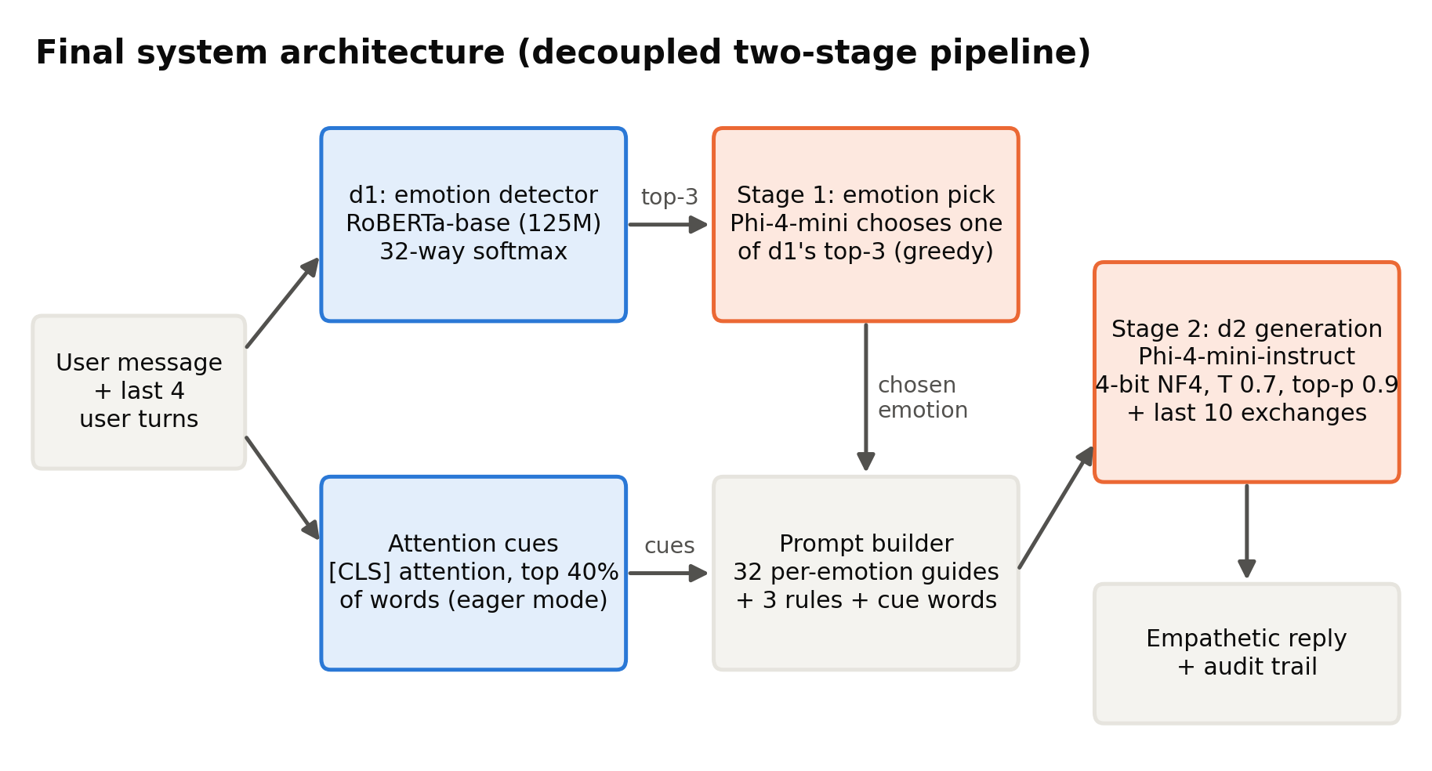
Figure: fig_final_architecture.png
Figure 4.2: Selected system architecture.

4.2.2 Emotion Detector Alternatives (d1)
GPT-2 Medium (initial design). The initial detector was GPT-2 Medium (355M parameters), a decoder-only model, fine-tuned on the dataset's situation descriptions. On those descriptions it reached 56.9% top-1 accuracy. When evaluated on the input it actually receives, the user's first message, accuracy fell to 48.2% (Table 4.x). The design was rejected for two reasons: it was trained on the wrong text, and a left-to-right decoder is a weaker architecture for classification than a bidirectional encoder.
Encoder candidates. We then trained four encoder backbones under identical conditions: the same first-utterance data, 4 epochs, maximum length 128, warmup ratio 0.06 and the same test split (Table 4.x, Figure 4.3). BERT-base reaches 48.8% top-1 and 81.7% top-5, ELECTRA-base 50.2% and 82.7%, and RoBERTa-base 50.1% and 85.0%. The three base models are statistically tied on top-1 accuracy (RoBERTa vs ELECTRA, p = 0.96; RoBERTa vs BERT, p = 0.11), but RoBERTa-base is significantly better on top-5 than both (p <= 0.0001). Because the selected design passes the detector's top-3 candidates to the generator, ranking quality matters more than the single top label, so RoBERTa-base was selected. RoBERTa-large (355M) is significantly better still (53.0% top-1, 87.2% top-5), but it costs 7.4 times the training time. When we swapped it into the final pipeline, no reply-quality measure improved (Section 5.3), so RoBERTa-base was kept.
Table: d1_evolution_mismatch_fix.csv
d1 version | Trained on | Evaluated on | Top-1 (%) | Top-5 (%) | Note
GPT-2 Medium (initial) | situation prompt field | situation text | 56.9 | 90.5 | Matches training text, but NOT what the system receives at inference
GPT-2 Medium (initial) | situation prompt field | first user message (real input) | 48.2 | 82.7 | Honest deployment number - train/inference mismatch costs ~9 points
RoBERTa-base (final) | first user message | first user message (real input) | 50.3 | 84.3 | Deployed checkpoint; top-3 = 76.5%

Table: d1_backbone_comparison.csv
Backbone | Parameters (M) | Learning rate | Batch size | Top-1 acc (%) | Top-5 acc (%) | Macro-F1 (%) | Train time (min)
bert-base-uncased | 110 | 0 | 8 | 48.8 | 81.7 | 47.9 | 8.6
google/electra-base-discriminator | 110 | 0 | 8 | 50.2 | 82.7 | 48.9 | 8.7
roberta-base | 125 | 0 | 8 | 50.1 | 85 | 49.1 | 8.8
roberta-large | 355 | 0 | 4 | 53 | 87.2 | 52.4 | 64.7

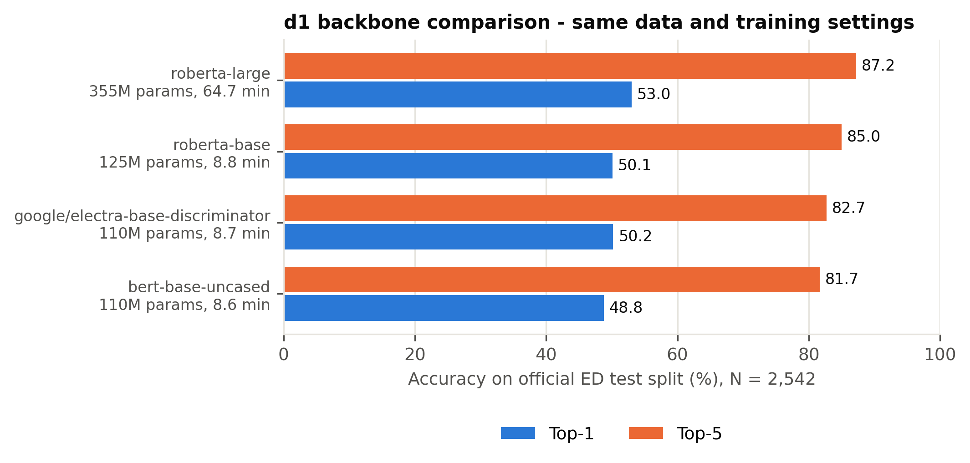
Figure: fig_d1_backbone_comparison.png

4.2.3 Response Generator Alternatives (d2)
To isolate the effect of the generator, we ran a controlled comparison: the same detector (RoBERTa-base), the same prompt and rules, the same 300 conversations and the same decoding settings, changing only d2 (Table 4.x). Qwen2.5-1.5B-Instruct, the initial generator, follows all rules in 57.7% of replies. Gemma-3-4B-it acknowledges feelings most often (96.7%) but obeys the length limit in only 27.7% of replies, averaging 133 words, so only 22.0% satisfy all rules. Phi-4-mini-instruct (3.8B, 4-bit) achieves the highest rule adherence, 65.3%, while keeping 96.0% of replies within length. Phi-4-mini was selected. An earlier base (non-instruction-tuned) candidate, Phi-2, was excluded because it has no chat template and could not follow system-prompt constraints.
Table: d2_bakeoff_candidates.csv
Setting ID | System | Ack (%) | One question (%) | Length OK (%) | All rules (%) | Mean words | Questions / reply | >1 question (%) | WASSA empathy (0-10) | WASSA SD | Emotion validation (%) | Context awareness (%) | N
bakeoff_qwen | RoBERTa d1 + Qwen2.5-1.5B d2 (top-1 emotion) | 67.67 | 84.33 | 100 | 57.67 | 34.72 | 1.07 | 10.33 | 4.78 | 1.31 | 25.33 | 31 | 300
bakeoff_gemma | RoBERTa d1 + Gemma-3-4B d2 (top-1 emotion) | 96.67 | 92 | 27.67 | 22 | 133.25 | 1.08 | 8 | 5.3 | 0.84 | 35 | 48.67 | 300
bakeoff_phi | RoBERTa d1 + Phi-4-mini d2 (top-1 emotion) | 72 | 94.67 | 96 | 65.33 | 80.45 | 1.05 | 5 | 4.89 | 1.04 | 28.33 | 36.67 | 300

4.2.4 Integration Alternatives: How d1's Output Reaches d2
d1 produces a full probability distribution, so there are several ways to use it. With the initial detector and generator, we simulated four variants on the same 300 conversations (Table 4.x). Argmax passes only the top emotion (63.7% all rules). Confidence-gated switches to hedged wording when d1 is unsure (63.3%), but only 28.7% of low-confidence replies actually hedged. Distribution lists every emotion above probability 0.05 (62.0%). Candidate-pick asks the generator to choose among the candidates and write the reply in the same call (54.0%). None beat argmax, and candidate-pick hurt rule adherence, which suggests that one generation call cannot both disambiguate the emotion and follow the rules.
This analysis motivated the two-stage design adopted in the final system. The true emotion is among d1's top-3 in 76.5% of test cases against 50.3% for top-1, so the wider candidate set is valuable, but merging several emotions into one prompt produces contradictory guidance. For example, disappointed and impressed call for opposite responses. The two-stage design therefore separates the choice into its own short, deterministic call and gives the generation call a single, coherent emotion-specific prompt.
Table: integration_variant_ablation.csv
Variant | Ack% | OneQ% | LenOK% | AllRules% | LowConfHedge%
argmax - top-1 emotion only (adopted) | 70.3 | 87.3 | 100 | 63.7 | -
confidence-gated - hedge when d1 is unsure | 71 | 88.3 | 100 | 63.3 | 28.7
distribution - list all emotions above p=0.05 | 72.7 | 83.7 | 100 | 62 | -
candidate-pick - d2 chooses AND generates in one pass | 65.3 | 82.7 | 100 | 54 | -

4.2.5 Monolithic and Retrieval Alternatives
To test whether a separate detector is necessary at all, four monolithic alternatives were simulated under the same rules and sample. Zero-shot: Qwen2.5-1.5B with a generic caring prompt and no detector. Monolithic fine-tuned: Qwen2.5-1.5B LoRA-tuned end to end on (user message, human reply) pairs. Single model, same size: Qwen2.5-1.5B instructed to silently identify the emotion and then respond under the three rules. Single model, bigger: the same prompt on Qwen2.5-7B in 4-bit. Their results are analysed in Section 5.2. In brief, the fine-tuned model failed every rule, zero-shot rarely asked the single required question, the same-size single model trailed the decoupled designs, and the larger single model performed best overall. Following the Pre-Thesis 2 panel's suggestion, we also simulated a retrieval-augmented variant that retrieves one or two similar training conversations with the same detected emotion (all-MiniLM-L6-v2 embeddings) and shows them to the generator as examples. Across two versions it reduced rule adherence from 63.7% to 54.3% and then to 43.7%, so it was not adopted (Table 4.x).
Table: rag_negative_result.csv
Variant | Ack (%) | One question (%) | All rules (%) | WASSA SD | Source
Initial pipeline (no retrieval) | 70.33 | 87.33 | 63.67 | 1.33 | result files
RAG attempt 1 (1-2 retrieved ED examples) |  | 76 | 54.3 |  | recorded in Full_Project_Documentation (outputs overwritten by attempt 2)
RAG attempt 2 (+ single-question filter + reminder) | 57 | 78 | 43.67 | 1.46 | result files

4.2.6 Specification of the Selected Design
Detector. RoBERTa-base with a 32-way classification head, fine-tuned on first utterances (learning rate 2e-5, effective batch 16, 4 epochs with early stopping, warmup 0.06, weight decay 0.01, gradient clipping 1.0, fp16). In conversation, d1 reads the concatenation of the user's last four turns. This window was best or tied-best in three of four long test scenarios. Six turns degraded two scenarios, because emotions from earlier turns competed with the current one.
Attention cues. d1 is loaded with the eager attention implementation, because the default sdpa backend returns no attention weights. We take the last layer's attention from the [CLS] position, average over heads, keep the top 40% of word spans (between 3 and 14), and expand sub-word pieces to whole words.
Stage 1 (emotion pick). Phi-4-mini receives the message and the three candidates with the instruction: "An automatic detector narrowed the person's likely feeling down to these options: {a}, {b}, {c}. Read their message and decide which ONE of those options best fits what they are actually expressing. Reply with ONLY that single word..." Decoding is greedy with at most 10 tokens. If the output does not name a candidate, the system falls back to d1's top-1. In simulation, every output parsed to a valid candidate.
Stage 2 (generation). The system prompt combines, in order, the chosen emotion, the cue words, the emotion-specific focus and avoid guidance, and the universal rules. Example for lonely:
You are a highly empathetic counselor. The user is feeling lonely.
The parts of their message that most signalled this feeling: {cues}.
Ground your reply in those specifics rather than responding generically.
Acknowledge the isolation itself, gently - the weight of it, not just 'you seem sad.'
Don't offer a surface-level fix like 'go meet people.' Don't act overly cheerful.
Follow these three rules strictly: 1. Acknowledge and validate their feelings deeply using 2 to 3 comforting sentences... 2. Share a reassuring thought that fits this specific feeling... 3. Ask EXACTLY ONE short, gentle follow-up question at the very end... Keep your entire reply under 100 words.
Guidance exists for all 32 emotions [[TEAM TO FILL: name the source document the per-emotion guidance was adapted from]]. Phi-4-mini runs in 4-bit NF4 with double quantisation and fp16 compute, sampling at temperature 0.7 and top-p 0.9 with at most 250 new tokens.
Conversation memory. d2 receives the last ten exchanges verbatim. From the second turn onward the question rule becomes optional and repeated phrasing is discouraged, so that a multi-turn conversation does not turn into an interrogation. The first turn keeps the original rules, so single-turn results remain comparable.
Table 4.x lists every setting of the selected design with its justification.
Table: configuration_and_hyperparameters.csv
Component | Parameter | Value | Justification | Evidence
d1 detector | Backbone | RoBERTa-base (125M) | Highest top-5 accuracy (85.0%) of the base-size encoders at equal top-1; RoBERTa-large adds 2.9 pp but has 2.8x the parameters, 7.4x the training time and gives no reply gain | Our measurement (Tables 4.5, 5.16, 5.25)
d1 detector | Training input | First user utterance | A detector trained on situation descriptions fell from 56.9% to 48.2% on the user messages it actually receives | Our measurement (Table 4.4)
d1 detector | Maximum input length | 128 tokens | 99.7% of training first utterances fit (mean 46.5 tokens) | Our measurement
d1 detector | Learning rate | 2e-5 | Inside the fine-tuning ranges recommended for BERT (2e-5 to 5e-5) and used for RoBERTa (1e-5 to 3e-5) | Devlin et al. (2019); Liu et al. (2019)
d1 detector | Effective batch size | 16 (8 per step x 2 accumulation) | Batch size recommended for BERT/RoBERTa fine-tuning; 8 per step fits in 8 GB | Devlin et al. (2019); Liu et al. (2019); hardware limit
d1 detector | Epochs and selection | Up to 4, early stopping (patience 1), best checkpoint by validation accuracy | BERT recommends 2-4 fine-tuning epochs; keeping the best validation checkpoint prevents over-fitting | Devlin et al. (2019)
d1 detector | Warm-up | Linear, 6% of steps | RoBERTa's fine-tuning setting; without warm-up our RoBERTa-large run diverged to 5.0% accuracy | Liu et al. (2019); our observation
d1 detector | Weight decay / gradient clipping | 0.01 / 1.0 | Weight decay as used for BERT; clipping at 1.0 is the Transformers default and keeps updates stable | Devlin et al. (2019); library default
d1 detector | Precision / seed | fp16 mixed precision / 42 | Fits the 8 GB GPU and trains faster; fixed seed for reproducibility | Hardware limit; convention
d1 detector (comparison only) | RoBERTa-large learning rate / batch | 1e-5 / 4 | The base settings diverged; 1e-5 is the lowest value of RoBERTa's fine-tuning range and batch 4 fits in memory | Liu et al. (2019); our observation
Two-stage selection | Candidates passed to d2 | Top-3 emotions | The true emotion is in the top-3 for 76.5% of messages against 50.3% for top-1, and most errors are neighbouring emotions | Our measurement (Tables 5.2, 5.4)
Two-stage selection | Stage-1 decoding | Greedy, at most 10 new tokens, fall back to d1 top-1 | A classification decision should be deterministic; 100% of stage-1 outputs named a valid candidate | Our measurement (Table 5.5)
Attention cues | Attention source | Final-layer attention from the [CLS] token, eager attention | RoBERTa classifies from [CLS]; the default sdpa attention returns no weights, so eager attention is required | Liu et al. (2019); our verification
Attention cues | Amount | Top 40% of tokens, at most 3 phrases | Design choice to keep the prompt short; not tuned (listed as a limitation) | Design choice
d2 generator | Model | Phi-4-mini-instruct (3.8B) | Highest rule adherence in the bake-off with detector and prompt fixed (65.3% vs 57.7% Qwen2.5-1.5B, 22.0% Gemma-3-4B) | Our measurement (Table 4.6)
d2 generator | Quantisation | 4-bit NF4, double quantisation, fp16 compute | NF4 preserves 16-bit quality while cutting memory about fourfold; measured peak use 3.40 GB on the 8 GB GPU | Dettmers et al. (2023); our measurement (Table 5.26)
d2 generator | Temperature | 0.7 | The developer's default for Qwen2.5-Instruct; identical for every system so differences come from design, not decoding | Qwen2.5 generation_config; fairness
d2 generator | Top-p (nucleus sampling) | 0.9 | Nucleus sampling avoids the repetitive, degenerate text of pure greedy or beam decoding; identical for every system | Holtzman et al. (2020)
d2 generator | Maximum new tokens | 250 | The prompt asks for under 100 words (about 130 tokens); the longest final reply is 119 tokens, so no reply is cut off | Our measurement
d2 generator | Word limit | Under 100 words in the prompt, scored at 120 | Short replies reduce burden on a distressed user; the 20-word margin tolerates small overshoots | Design choice
d2 generator | Repetition penalty |  | Kept identical for all systems; a penalty of 1.1 is deferred because it would change the judged outputs | Fairness; future work
Conversational agent | d1 context window | Last 4 user turns | Context matters for emotion recognition in conversation; 4 turns was best or joint best in 3 of 4 long scenarios, 6 turns degraded 2 | Poria et al. (2019); our scenario tests
Conversational agent | d2 memory | Last 10 exchanges, verbatim | Support conversations are short; verbatim history avoids losing emotional detail through summarisation | Design choice
Conversational agent | Question rule | Mandatory on turn 1, optional afterwards | A question in every reply turns a long conversation into an interrogation; turn 1 keeps the evaluated rules | Design choice
LoRA baseline | Rank / alpha | 16 / 32 | Low ranks are sufficient to adapt attention weights; alpha = 2 x rank scales the update | Hu et al. (2022)
LoRA baseline | Target modules | q, k, v, o attention projections | The weight matrices studied for adaptation in LoRA | Hu et al. (2022)
LoRA baseline | Learning rate / dropout / weight decay | 2e-4 / 0.1 / 0.01 | LoRA's GPT-2 settings; QLoRA uses 2e-4 and dropout 0.1 for models up to 13B | Hu et al. (2022); Dettmers et al. (2023)
LoRA baseline | Warm-up / effective batch / optimiser | 6% linear / 16 (2 x 8) / paged AdamW 32-bit | Same warm-up rule as the detector; batch fits 8 GB; paged optimisers avoid memory spikes | Liu et al. (2019); Dettmers et al. (2023)
LoRA baseline | Epochs and selection | Up to 3, best epoch by validation loss, early stopping (patience 1) | Validation loss rose after epoch 1 (1.4607 to 1.4626), so epoch 1 was kept | Our training log
LoRA baseline | Maximum length | 256 tokens | The longest training pair is 177 tokens, so nothing is truncated | Our measurement
LoRA baseline | Padding token | Qwen end-of-text token (endoftext) | Using the end-of-turn token as padding masked it from the loss: the original run never learned to stop (99% of replies hit the token limit) | Our finding (adjustment A11)
AI judges | Decoding | Temperature 0, JSON-only answer | Removes sampling noise so the same reply always gets the same score | Design choice
AI judges | Sample | 64 conversations: shortest and longest per emotion | Covers all 32 emotions and both short and long messages within the 50-requests-per-day limit | Design choice; resource limit
AI judges | Panel | Nemotron 3 Ultra + gpt-oss-120b, blind | Different developers from our models avoid self-preference; a panel reduces single-judge bias | Panickssery et al. (2024); Verga et al. (2024)
WASSA classifier | Model | hyy33, WASSA 2024 Track 2 | Trained on human empathy ratings of conversation turns; r = 0.544 with human ratings | Giorgi et al. (2024); Yang et al. (2024)
Statistics | Evaluation sample | 300 test conversations, seed 42 | Fixed before any experiment and identical for every system, so all comparisons are paired | Design choice
Statistics | Tests | McNemar exact (binary), Wilcoxon signed-rank (scores) | Paired tests matched to the data type; Wilcoxon does not assume normal differences | McNemar (1947); Wilcoxon (1945)
Statistics | Confidence intervals | Paired bootstrap, 10,000 resamples | More than the 1,000 resamples recommended for percentile intervals, giving stable limits | Efron and Tibshirani (1993)
Statistics | Multiple comparisons | Holm correction; significant only if adjusted p < 0.05 and CI excludes zero | Controls the family-wise error rate with more power than Bonferroni | Holm (1979)
Human evaluation | Design | 13 items (11 scored + 2 attention checks), 3-way forced choice | Keeps the form short enough to avoid rater fatigue; preference judgements follow comparable studies | Cao et al. (2025); Wu et al. (2025)
Resource benchmark | Protocol | 50 messages, 3 warm-up, one system per run | Warm-up removes first-call overhead; separate runs keep memory readings clean | Design choice

4.2.7 Simulation and Verification
Each alternative was verified functionally before full evaluation. Small smoke-test runs confirmed that outputs were well formed and that model-specific details were handled: Phi-4-mini's end-of-turn token differs from its end-of-text token, Gemma's chat template has no system role, and Phi-4-mini uses fused attention projections. Every design was then simulated on the same 300 held-out conversations under identical decoding settings, and detector candidates on the full 2,542-example test split. Two automatic safeguards protect the selected design: a hard failure if the detector returns no attention weights, and logging of whether each stage-1 decision parsed successfully (100% did). The outcome of these simulations determined the selections above and is analysed in full in Chapter 5.

Traps
- Never reuse the June Table 3.1 (GPT-2 56.64% vs Qwen2.5-0.5B 35.93% vs TinyLlama 16.91%). The numbers come from different datasets.
- The integration ablation (4.2.4) used the initial GPT-2 + Qwen pipeline. Say so, as the draft does.
- Keep numbers here to what justifies each choice. Significance tests on the final system belong in 5.3.
- The history-window evidence (4 turns) comes from qualitative scenario tests recorded in the code, not a large-sample experiment. Describe it as scenario testing.

